Linux Practical

Using an OS – Character vs. Graphical User Interfaces

In order to use a computer system, commands must be issued to the OS. An input device like a keyboard or mouse can be used to do this. If only the keyboard is used to issue commands to the OS, then typically a character (command-line) user interface (CUI) is being used. If the primary input device used to issue OS commands is the mouse, then a graphical user interface (GUI) is being used. Some OS, such as Linux, UNIX and DOS have CUIs although the MAC OS and Microsoft Windows are GUI based. Note that Linux, UNIX and DOS can provide a GUI through an appropriate command issued to the OS via a script or command line. You may have already done this today in the Linux environment to move from the console, a CUI, to the GNOME desktop environment, a GUI by using the startx command. You will all be very familiar with using GUIs, but a lot of the work you will do in the remainder of the lab sessions in this course will involve using a CUI. This is because

- GUIs give you an automated set-up with minimal flexibility (what you can and cannot do is determined largely according to how the interface was programmed)
- GUIs add an extra software layer between you and the task you wish to perform making the task a little slower.
- Often Linux is used as a server of some description where no GUI is installed so knowing how to work at the command line is mandatory.

In the first practical you got a chance to explore Fedora at a very high-level, using the GUI, since it is important for you to see that Linux can operate comfortably in a desktop environment scenario. However, network and system administrators cannot always use a GUI to carry out their tasks as they will often need to meddle with the heart of the system, something that is often impossible from the GUI environment. Often, such work can only be carried out by communicating with the system using a CUI called the shell. A shell is simply a command interpreter.

Shell tasks can be performed much faster than having to pick up the mouse, click on an icon or pull an option from a menu etc., and you will hopefully find this to be the case after a while, once you have got used to some of the commands. Also, as mentioned earlier, all possible command options (switches) are available to you from the command-line, whereas GUIs are limited in their capabilities. In the Linux graphical environment, the shell will be available to you from a so-called terminal window. The default shell you will use for this course is called the bash (Bourne Again Shell).

Exercise 1: Launching the Terminal Window and Creating a Shortcut for it

Assuming you are booted up to Linux, login on the console as per the last practical using your tnumber and password and then issue the startx command to go into the GNOME desktop environment.

You should now launch the GNOME terminal. Do this by going to Applications->System Tools->Terminal.

The terminal window will look something similar to the screenshot below when it is launched and your prompt should also look like this, or at least similar to it.

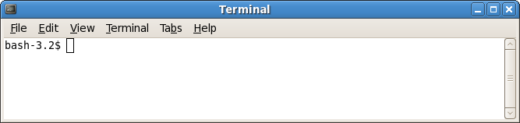
You should now create a shortcut for this application on the desktop as you will be using it on a regular basis.

Syntax for Linux commands

The general syntax for any Linux command will be as follows:

$command [-option(s)] [option argument(s)] [command argument(s)]

where

$ is the shell prompt from the computer as indicated in the terminal screenshot above
anything enclosed in [ ] is optional
command is the name of the valid Linux command for that shell in lowercase letters
[-option(s)] is one or more modifiers that change the behaviour of the command
[option argument(s)] is one or more modifiers that change the behaviour of the option
[command argument(s)]is one or more objects affected by command, these are normally files, directories or processes

Note that a space always separates the command, option, option argument and command argument but no space is necessary between multiple options or multiple option arguments.

Note also that the order of multiple options or multiple option arguments is irrelevant

The return key must always be pressed to submit the command to the shell process for interpretation.

Most importantly, remember always that Linux is case-sensitive unlike DOS, Windows and MAC and that all commands will always be in lowercase.

Some Basic Linux Commands

Today the emphasis is on showing you some of the more basic Linux commands – you will encounter many of them again in future labs.

Exercise 2: Getting help on Linux commands using man

Linux comes with a set of help reference manuals that are there to make your life easier and help is available for all commands, system calls and library calls available in Linux. So, for example, to access help on using the Linux passwd command, which may be used to alter your system password, you just type

man passwd

and the help manual page for this command will appear.

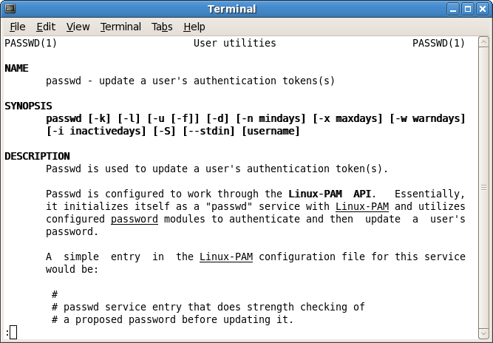
Notice that you lose the prompt as the man process executes and fills the terminal window with textual information. In order to see the next page of information, press the spacebar. In order to scroll line by line hit return. In order to go back to a previous page use Page Up. When you have read as much as you need or have come to the end of the man document, just hit q to quit. This terminates the man process and returns control to the shell that called it so you get the prompt back again.

In order to access all the man pages associated with a particular command or call, you can just issue the -a option to the man command.

man -a passwd

In this case when you reach the end of the first man page for the command, you can just hit q and continue on to subsequent pages.

Another useful switch for the man command is the -k option. This option can be used to allow the user specify a particular keyword and a search for all man pages that contain that keyword will ensue. This is useful when you cannot remember the specific name of the command you need information about but know the topic the command deals with.

Now you should type

man –k password

and notice that you now get back just the man page headers for those man pages that refer to the keyword “password”. There will be numerous commands that deal with passwords in some shape or form and all of these will be returned. In amongst them you will see the passwd command that we have been looking at.

If the previous command only returns “Nothing appropriate” then it means that the “man-db” database has not already been created. This database is used by certain commands, or switches to certain commands, to elicit information from them. To create this database at the command line just type the command

mandb

Note that you should be logged in as root to create this database as it is an administrator level operation. The creation of this database takes a little bit of time.

Exercise 3 Getting help on Linux commands using info

The info command is an alternative to man for getting information on various Linux commands. The GNU project delivers most of its online manuals in the .info format and so the info command can be used to read such manuals. There are links between the man and info pages and, in most cases, it is possible to get information about any command, system, or library call from either tool. The info help manuals are sometimes considered to be more up to date than the man pages and some users think they are easier to read than man. Navigation is similar to using the man pages, spacebar (or Page Down) for scrolling through one page at a time and return for scrolling down one line at a time. The Page Up key can be used for moving back up one page and q can be used to quit. One difference in use is that with info, the utility just moves on to the details of the next command in the document, it doesn't just end when it reaches the end of the pages for the command you are interested in.

Use the info command now as follows to obtain information on the ls command

info ls

Exercise 3: Getting a very brief description of a Linux command using whatis

To get a very brief description of what the ls command does type

whatis ls

The command returns more than one entry here. One entry concerns using the command ls as indicated in the man pages and the other contains information on the command from the POSIX Programmers Manual.

It is also possible to get information on several commands together by just passing more arguments to the command. To try out this type

whatis man passwd whatis

Exercise 4: Practicing with the man, info and whatis commands

- Use the whatis command to find out what the pwd command does? print name of current/working directory

- Use the man command to find out what the ls command does?
List information about the FILEs (the current directory by default).

Sort entries alphabetically if none of -cftuvSUX nor --sort.

- Use the man or info command to find out what the command ls -l allows you to do?
use a long listing format

- Use the man or info command to find out which option on the ls command will give you the files, sorted by file size, largest first
ls -lS

- Use whatis to find out what passwd command does
modify a user's password

Exercise 5: Finding Graphical Help

Although it is vital that any network or system administrator working under Linux is able to obtain help in textmode using the commands we have been looking at, anyone working in a desktop environment can normally work straight from a GUI. The Help is located in Applications – Accessories - Help

Of course, you will be able to find online documentation for the man or info pages also without too much difficulty. One useful location is http://www.linuxcommand.org/superman_pages.php. Use this now to find help on the cd command. What does the cd command allow you to do?
Change working directory

Exercise 6: Find out who you are currently logged on as using whoami

At the command prompt type

whoami

This will tell you what your current login (username) is. This might seem like a trivial command but there are circumstances where this command can be very useful e.g. if you are performing a Linux session and you have more than 1 username e.g. you have administrative rights where you can also make use of the username called root and perhaps other user names e.g. testname along with your regular account name e.g. t00012345.

Exercise : find out what the su command does
run a shell with substitute user and group IDs

At the command line you should now log in as root by typing

su root

You will be asked for the root password. It is “itt12345”. Once you have supplied this, you will become the root user and not the “regular” user you had been. Your prompt will change also, signifying that you are root, with a # instead of a $.

Use the whoami command again – you should see that your current login is now root.

Being an administrator means that test user accounts are often created for various purposes and with so many possible usernames being used it is easy to forget which one you are currently using during a session, so whoami comes in very handy here.

Exercise 7: Find out who is logged on to the system + extra information using who

Now type

who

This command gives you a number of pieces of information related to your current login session.

It tells you the username you used originally to log in (so if I logged in originally as t00034567 and then switched during the session to become root user, the who command would give back my ‘t’ number rather than root – whoami on the other hand would give me back root at this point).

It also tells you the name of the terminal line(s) being used and the login time. In the case of a centralised Linux system where there would be multiple users sitting at terminals all attached to a central Linux server (similar to the time-sharing systems we looked at in the lectures), the who command would usually return the details for all users logged on to the server which was very handy as you could tell who was logged on and get in touch with that person if necessary (for example, using the UNIX “talk” utility).

Exercise 8: Find out the hostname of the computer you are on using uname -n

Now type

uname -n

This will tell you your machine’s hostname – it will be something like labpc in your case as the Linux OS has been installed locally.

Although the Linux system is installed locally on the machine, that doesn’t mean that you cannot access the LAN or indeed the Internet from the Linux system, however. As you know, this lab sheet has been put on the X: drive under Windows and you can access it from the location called /share under the Linux filesystem or the “Lab Share” icon on your desktop. Also, you wouldn’t have been able to access your Linux account at all were you not able to login to the ITT LAN with your ‘t’ number and the contents of your Linux account will reflect that of your Windows account as they are “mapped” to the one server machine for storage.

Exercise 9: Find out Various System Information using uname -a

You should now issue the command

uname -a

to retrieve all the information the uname command can give you.

Name any 4 other pieces of information that this option gives? If you are not sure what the information given means, check out the uname command using the man command.

1. uname -n -- brings up the node host name
2. uname -s -- print the kernel name
3. uname -m -- print the machine hardware name
4. uname -r -- print the kernel release

Exercise 10: Find out the calendar for a particular month and the current date and time respectively using cal and date

At the command prompt type

cal 3 2008

You get back the calendar for the month indicated.

To find the calendar for the current month it is sufficient to issue the command cal without any arguments.

Now use the cal command to find out what day of the week the 21st July 1786 fell on.
Friday

Now type

date

You get back the current system date and time information.

What option would you need to use to set the system time? date -s

Now attempt to set the system time to 02:12. What happens? Does this make sense?
It changes the system time to 02:12. (as long as you are logged in as root)

Exercise 11: Unmounting Devices, Logging Out and Shutting Down

Before you log off it is good practice to close all open windows and to unmount any devices such as memory sticks that you have attached to the system. To unmount a device simply right-click its icon on the desktop and select “Unmount Volume”. Doing this helps to prevent possible data loss and makes the shutting down process cleaner.

Now, to log off simply go to System->Log Out t00012345. Doing this will log you off, save all your session settings, and take you back to the console but the system will still remain operational.

In order to shut the system down and reboot, you need to hit ALT+CTRL+DEL at the console. This will begin the shutdown process and reboot the machine.

